CSA0421 – OPERATING SYSTEMS
LIST OF PROGRAMS
NAME:J.P.BADRI
REG NO:192524301
EXP:1
1. Create a new process by invoking the appropriate system call. Get the process identifier of the
currently running process and its respective parent using system calls and display the same
using a C program.
Code:
#include <stdio.h>
#include <windows.h>
int main(void)
{
STARTUPINFOA si;
PROCESS_INFORMATION pi;
char command[] = "cmd.exe /c echo Child Process Running";
ZeroMemory(&si, sizeof(si));
si.cb = sizeof(si);
ZeroMemory(&pi, sizeof(pi));
if (CreateProcessA(
NULL, command, NULL, NULL, FALSE,
CREATE_NO_WINDOW, NULL, NULL, &si, &pi))
{
printf("Parent Process ID: %lu\n",
(unsigned long)GetCurrentProcessId());
printf("Child Process ID: %lu\n",
(unsigned long)pi.dwProcessId);
WaitForSingleObject(pi.hProcess, INFINITE);
CloseHandle(pi.hProcess);
CloseHandle(pi.hThread);
}
else
{
printf("Process creation failed: %lu\n",
(unsigned long)GetLastError());
}
return 0;
}

Output:
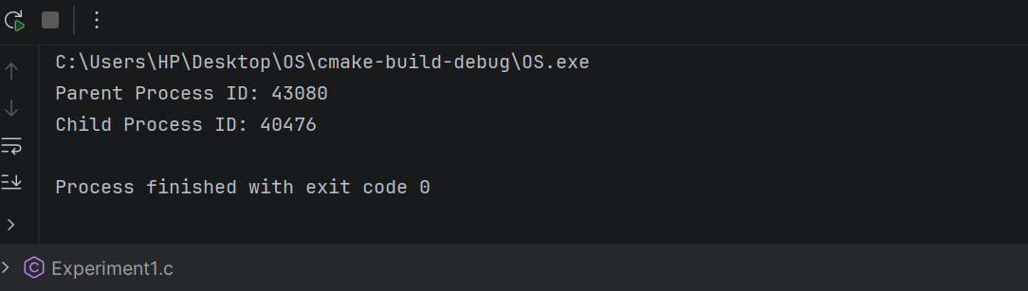
Exp2:
2. Identify the system calls to copy the content of one file to another and illustrate the same using
a C program.
CODE:
#include <stdio.h>
#include <stdlib.h>
int main()
{
FILE *src, *dest;
char buffer[1024];
size_t n;
src = fopen("input.txt", "r");
if (src == NULL)
{
printf("Cannot open input.txt\n");
return 1;
}
dest = fopen("output.txt", "w");
if (dest == NULL)
{
printf("Cannot create output.txt\n");
fclose(src);
return 1;
}
while ((n = fread(buffer, 1, sizeof(buffer), src)) > 0)
fwrite(buffer, 1, n, dest);
fclose(src);
fclose(dest);
printf("File copied successfully.\n");
return 0;
}

OUTPUT:
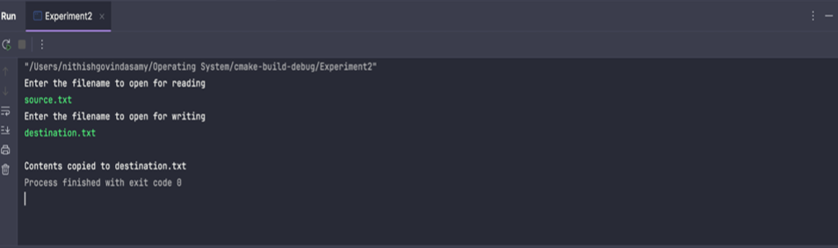

Exp:3
3. Design a CPU scheduling program with C using First Come First Served technique with the
following considerations.
a. All processes are activated at time 0.
b. Assume that no process waits on I/O devices.
Code:
#include <stdio.h>
int main()
{
int n, i;
int bt[20], wt[20], tat[20];
float avgwt = 0, avgtat = 0;
printf("Enter number of processes: ");
scanf("%d", &n);
for (i = 0; i < n; i++)
{
printf("Enter burst time for P%d: ", i + 1);
scanf("%d", &bt[i]);
}
wt[0] = 0;
for (i = 1; i < n; i++)
wt[i] = wt[i - 1] + bt[i - 1];
printf("\nProcess\tBT\tWT\tTAT\n");
for (i = 0; i < n; i++)
{
tat[i] = wt[i] + bt[i];
avgwt += wt[i];
avgtat += tat[i];
printf("P%d\t%d\t%d\t%d\n",
i + 1, bt[i], wt[i], tat[i]);
}
printf("\nAverage Waiting Time: %.2f\n", avgwt / n);
printf("Average Turnaround Time: %.2f\n", avgtat / n);
return 0;
}

Output:
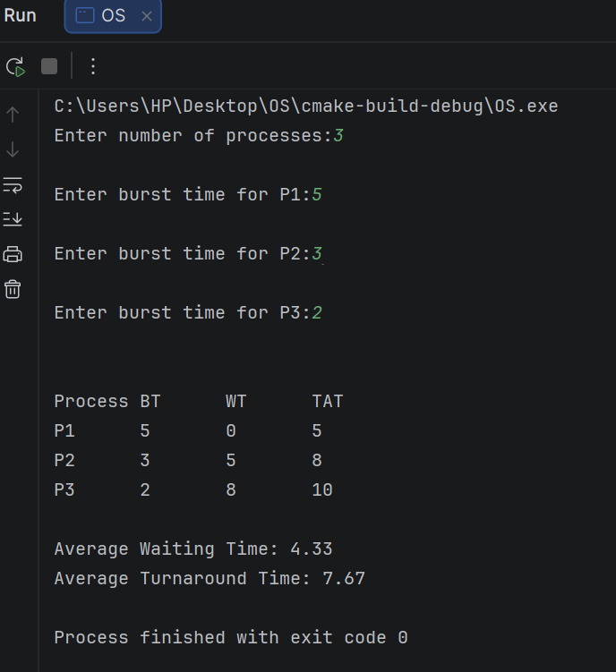

4. Construct a scheduling program with C that selects the waiting process with the smallest
execution time to execute next.
Code:
#include <stdio.h>
int main()
{
int n, i, j, temp;
int bt[20], wt[20], tat[20], p[20];
float avgwt = 0, avgtat = 0;
printf("Enter number of processes: ");
scanf("%d", &n);
for (i = 0; i < n; i++)
{
p[i] = i + 1;
printf("Enter burst time for P%d: ", p[i]);
scanf("%d", &bt[i]);
}
for (i = 0; i < n - 1; i++)
{
for (j = i + 1; j < n; j++)
{
if (bt[i] > bt[j])
{
temp = bt[i];
bt[i] = bt[j];
bt[j] = temp;
temp = p[i];
p[i] = p[j];
p[j] = temp;
}
}
}
wt[0] = 0;
for (i = 1; i < n; i++)
wt[i] = wt[i - 1] + bt[i - 1];
printf("\nProcess\tBT\tWT\tTAT\n");
for (i = 0; i < n; i++)
{
tat[i] = wt[i] + bt[i];
avgwt += wt[i];
avgtat += tat[i];
printf("P%d\t%d\t%d\t%d\n",
p[i], bt[i], wt[i], tat[i]);
}
printf("\nAverage Waiting Time: %.2f\n", avgwt / n);
printf("Average Turnaround Time: %.2f\n", avgtat / n);
return 0;
}

Output:
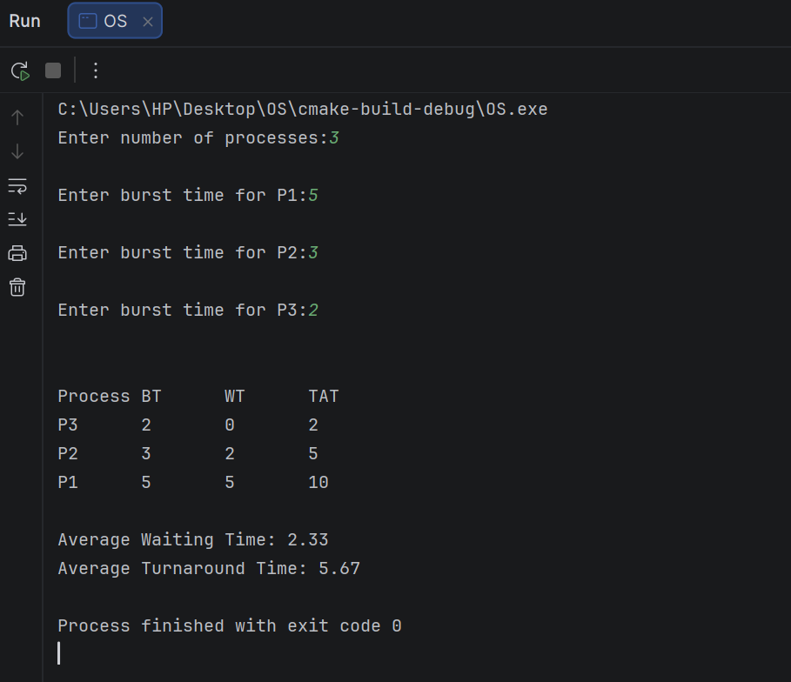

5. Construct a scheduling program with C that selects the waiting process with the highest
priority to execute next.
Code:
#include <stdio.h>
int main()
{
int n, i, j, temp;
int bt[20], pr[20], wt[20], tat[20], p[20];
float avgwt = 0, avgtat = 0;
printf("Enter number of processes: ");
scanf("%d", &n);
for (i = 0; i < n; i++)
{
p[i] = i + 1;
printf("Enter burst time for P%d: ", p[i]);
scanf("%d", &bt[i]);
printf("Enter priority for P%d: ", p[i]);
scanf("%d", &pr[i]);
}
for (i = 0; i < n - 1; i++)
{
for (j = i + 1; j < n; j++)
{
if (pr[i] > pr[j])
{
temp = pr[i];
pr[i] = pr[j];
pr[j] = temp;
temp = bt[i];
bt[i] = bt[j];
bt[j] = temp;
temp = p[i];
p[i] = p[j];
p[j] = temp;
}
}
}
wt[0] = 0;
for (i = 1; i < n; i++)
wt[i] = wt[i - 1] + bt[i - 1];
printf("\nProcess\tPriority\tBT\tWT\tTAT\n");
for (i = 0; i < n; i++)
{
tat[i] = wt[i] + bt[i];
avgwt += wt[i];
avgtat += tat[i];
printf("P%d\t%d\t\t%d\t%d\t%d\n",
p[i], pr[i], bt[i], wt[i], tat[i]);
}
printf("\nAverage Waiting Time: %.2f\n", avgwt / n);
printf("Average Turnaround Time: %.2f\n", avgtat / n);
return 0;
}

Output:
